Template: uses HTML (template) with two way data binding

Reactive: manages the form and its data in the component code

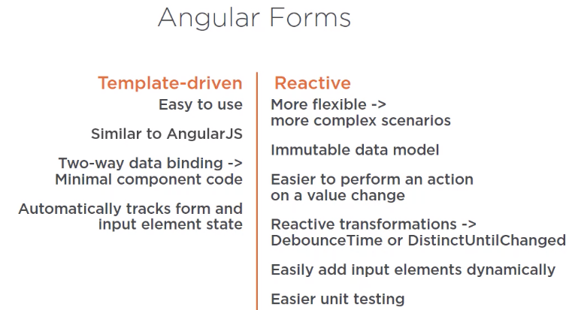

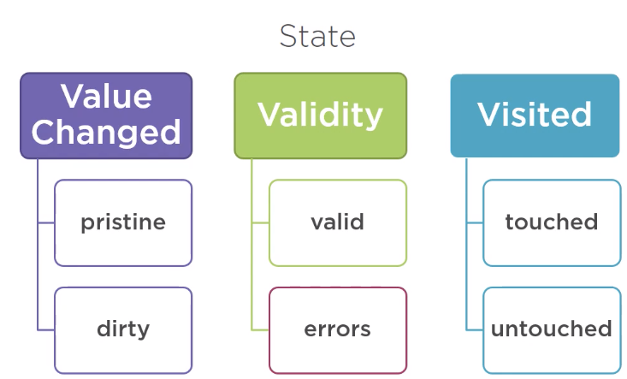

Pristine: unchanged (all must be pristine to be considered pristine)

Dirty: changed (if one input element is dirty, then the whole form is dirty)

Form Control

-tracks the value and state of an individual input elements

Form Group

-tracks the value and state of a group of FormControls

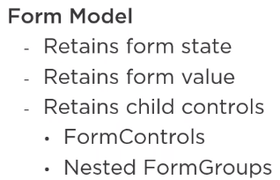

Form Model:

-Data structure that represents the HTML form

-don’t confuse the form model with the data model that we use with data binding

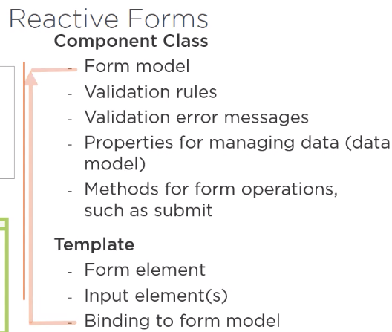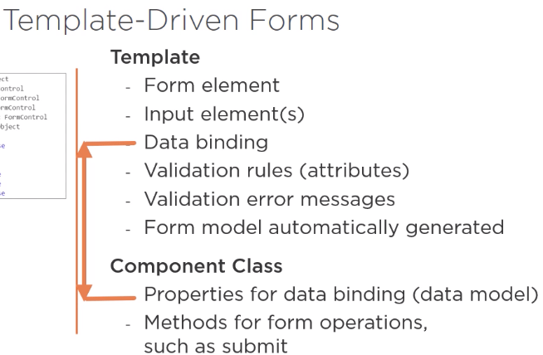

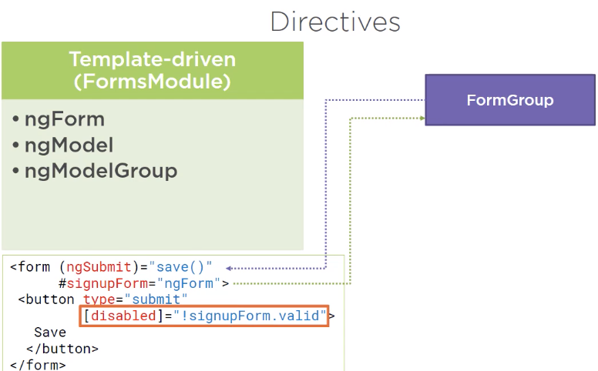

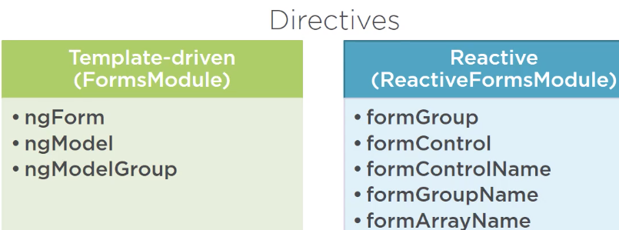

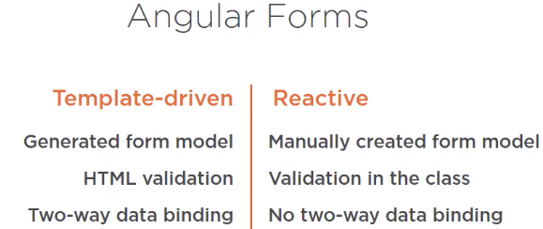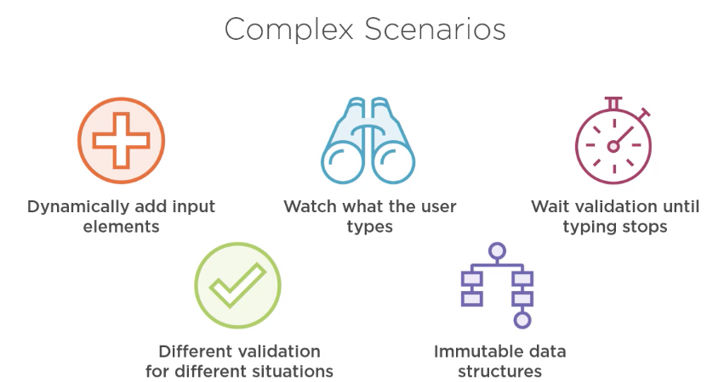

Template:

-Angular generates the form model by creating FormGroup and FormControl instances

Reactive

-We create the form model by creating FormGroup and FormControl ourselves in our component class

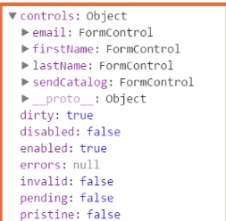-Then bind the template to the form model, this means that our form is not directly modifying our data model

Form Model

-requires one FormGroup (root) that represents the entire form

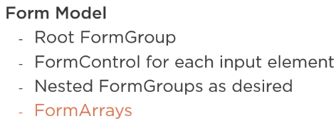

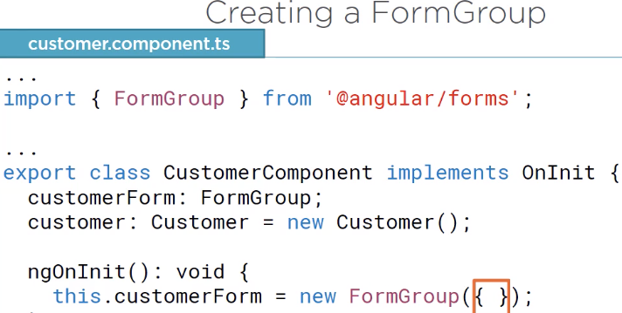

-Could have put it in the constructor, but selected to use ngOnInit to ensure the component and template are initialized before building the form model 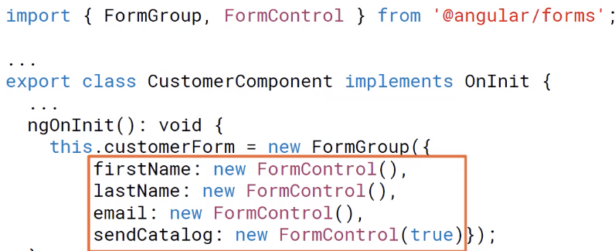

-Inside FormGroup,, we pass in an object that contains FormControls and nested FormGroups



-Each control is defined with a key (control name), value (AbstractControl) pair.

-AbstractControl is the base class for FormControl and FormGroup

-This structure (orange box) is the form model and tracks the form value and state

-Don’t confuse this form model (defines the set of FormGroups/Controls that match up with the HTML form and input elements) with our data model (customers = new Customer()) which defines the data passed to and from a back-end server

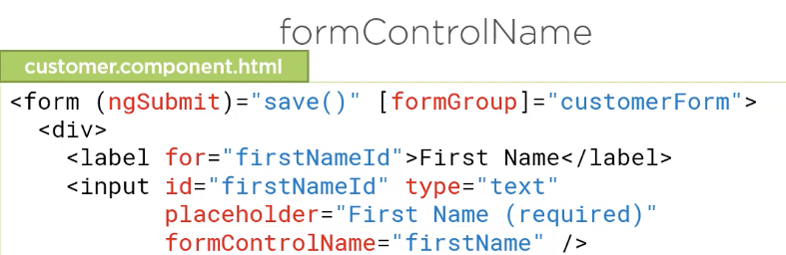

formGroup

-use this directive to bind the form element in the template to the root FormGroup of our form model (customerForm from our component class)

- The form then knows not to build its own form model

formControlName

-to bind each input elements to its associated FormControl

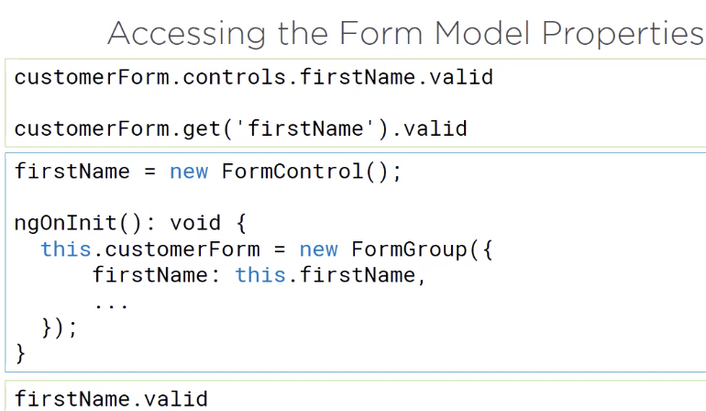

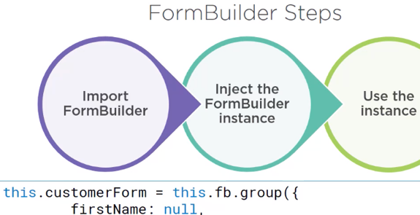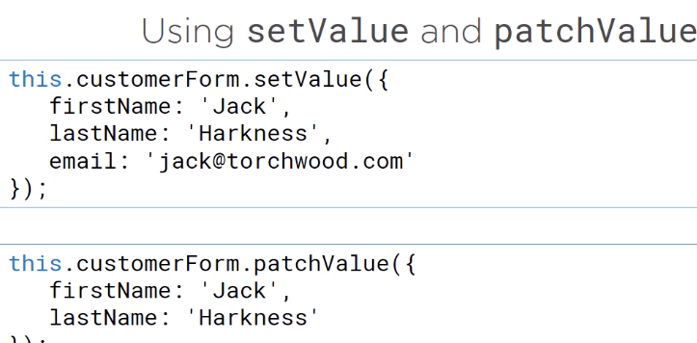

Patch values: if we only want to subset of the values

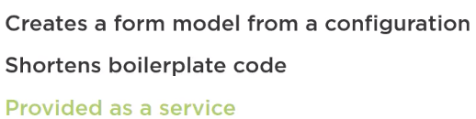

FormBuilder

-is a class we can use to build reactive forms

-think of it as a factory that creates FormGroups/Controls

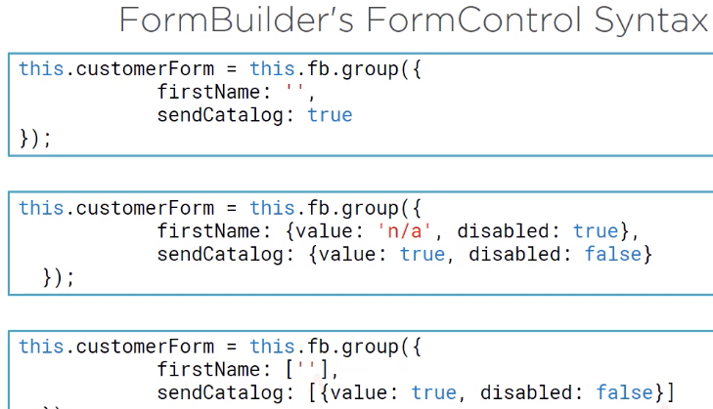

-The group method returns an initialized root FormGroup instance with all associated FormControls and nested FormGroups

-First element of the array is the default value expression or the object with the value and disabled state

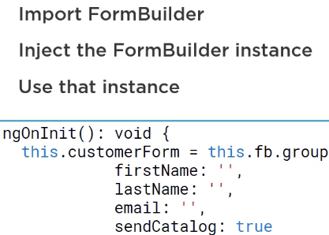

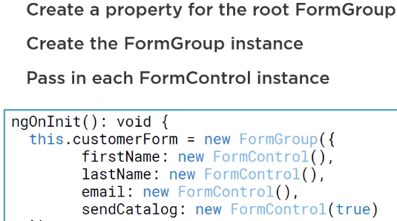

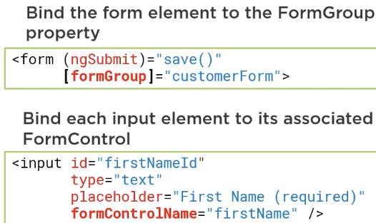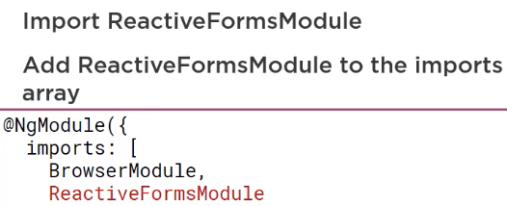

Validation

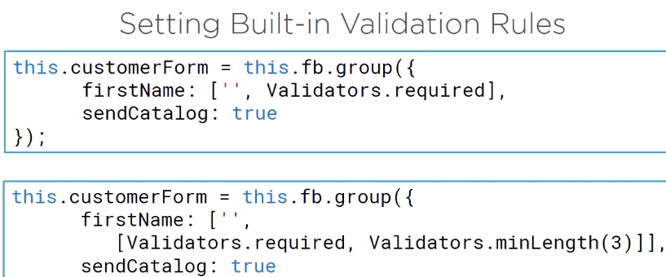

-Validators class and specify the name of the desired validation rule

-use an array to specify multiple validation rules

-3rd element of the array is asynchronous validation and is used most for calling server-side validation method

-To minimize asynchronous calls, asynchronous validators are not executed until all synchronous validators pass validation

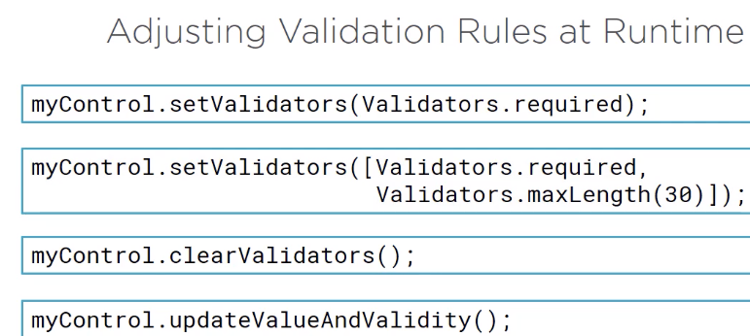

-Updating the validators doesn’t cause the validation status of the control to be reevaluated. If we want the control validation to be evaluated, call updateValueAndValidity

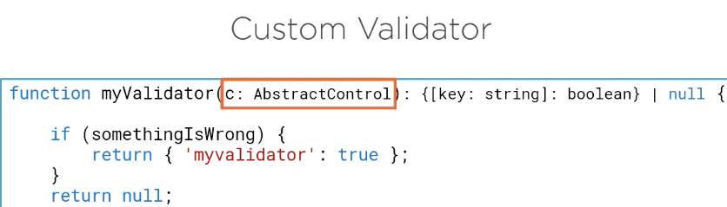

-Validator functions takes one parameter,, the FormControl or FormGroup being validated

-We type the parameter using the abstract class so we can use control or group

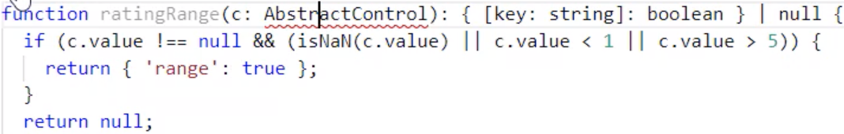

-returns null if valid

-The key is a string and defines the name of the broken validation rule

-If the validator will only be used by this component, then add it above the @Component otherwise put it inside its own file

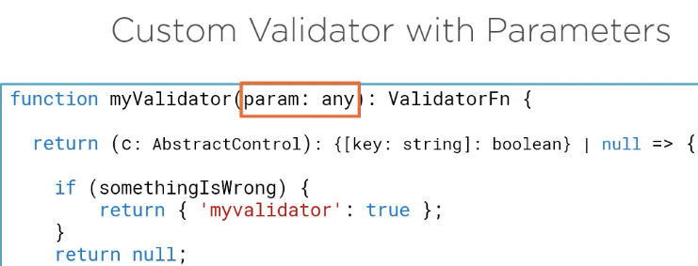

Because a validator functions can only take one parameter (the AbstractControl), so we need to build a factory function that returns the validator function that returns the validator function

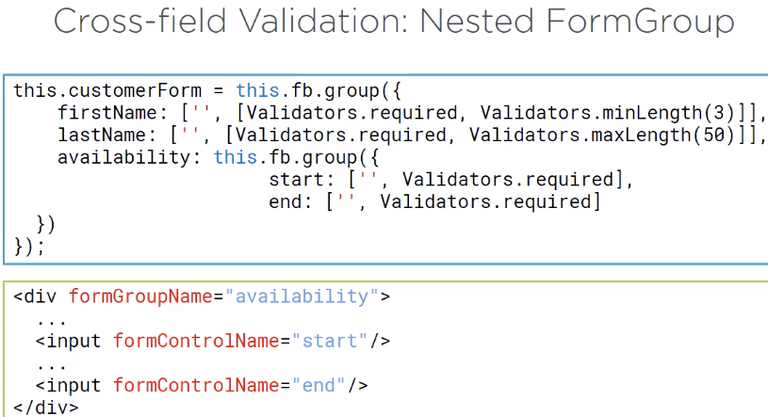

-Common use case is start, end date or confirming passwords

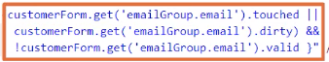

-since it is nested, must reference like this

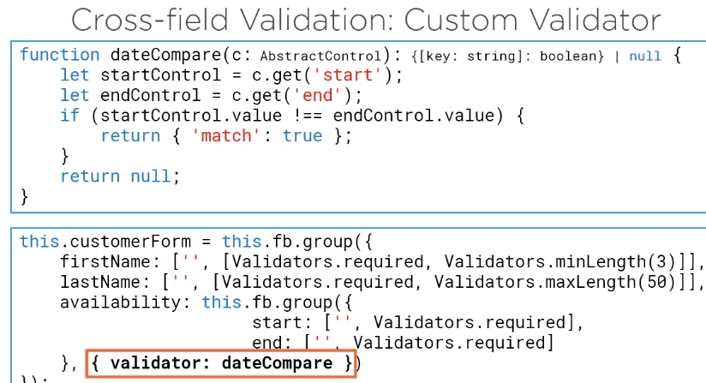

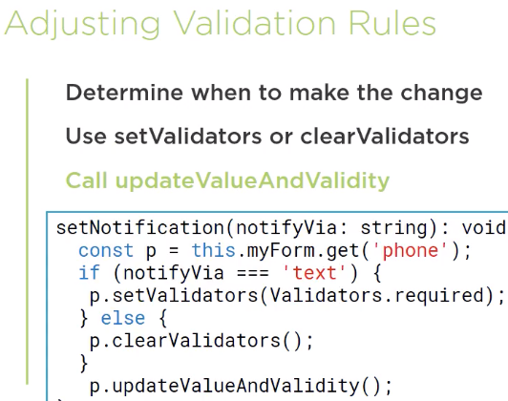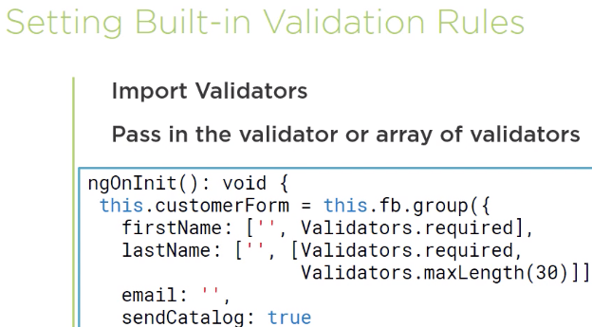

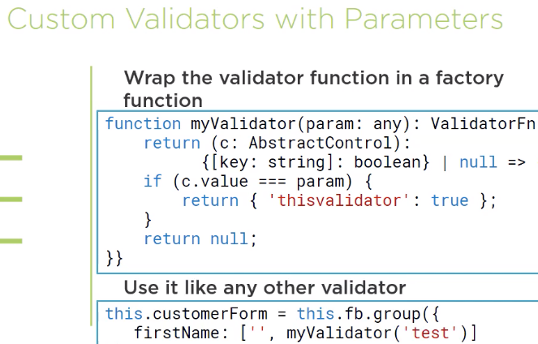

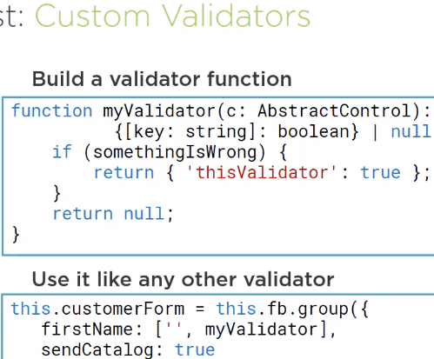

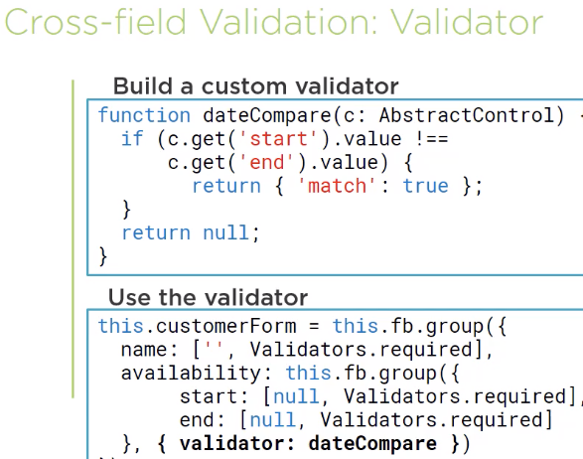

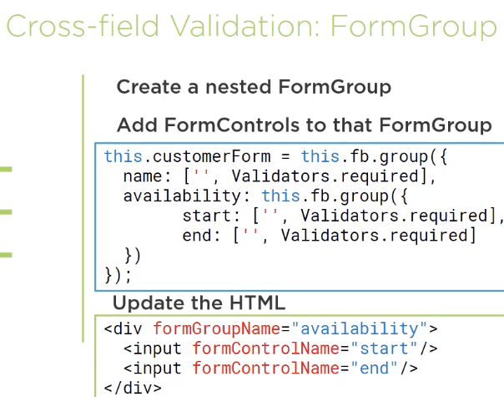

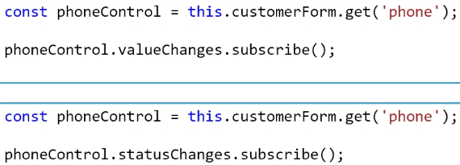

valueChanges

-property that allows us to watch for changes

-emits an event every time the value of a control changes (interface or programmatically)

-return Observable<any> (think of it as a collection of events that arrive asynchronously over time)

statusChanges

-emits event on changes the validation state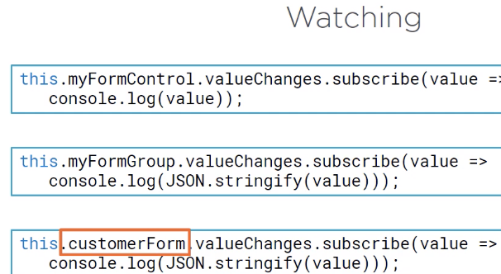

-FormGroup, any of the FormControls or nested FG are changes, an event is emitted

-return value is the set of key and value pairs

-CustomerForm, watch for any change over the entire form

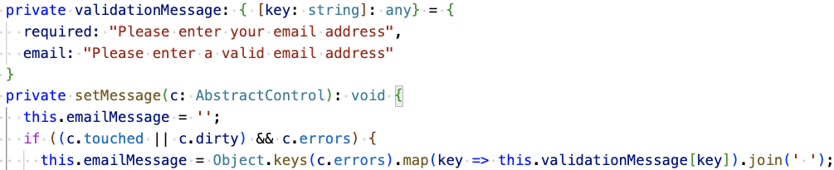

Otherwise: this error appears



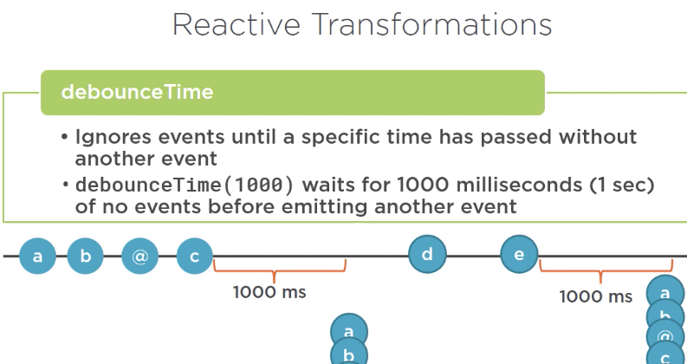

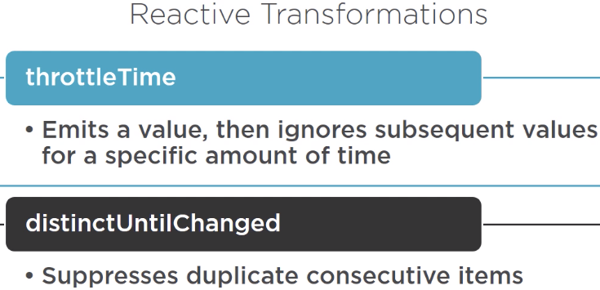

-throttleTime useful when you receive too many events (mouse movements)

-distinctUntilChanged useful when tracking key events to prevent getting events when only the Ctrl or Shift keys are changed



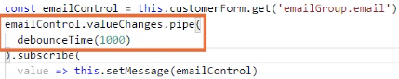

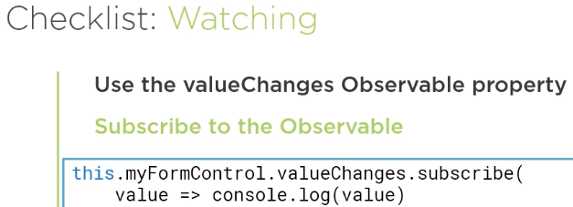

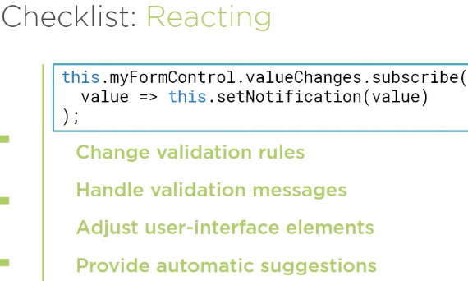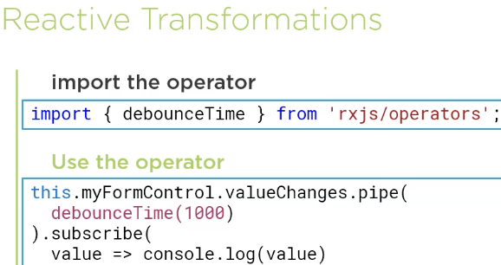

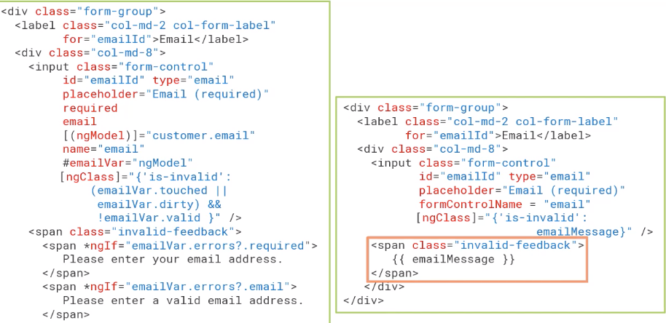

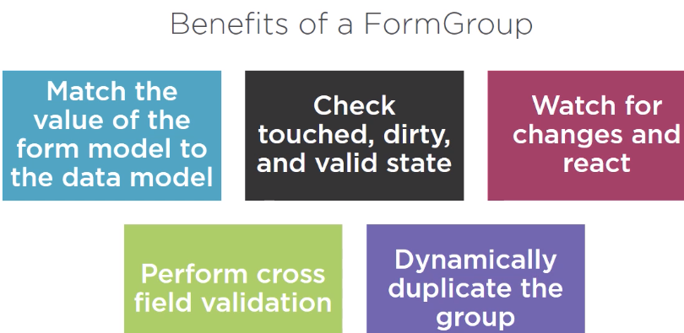

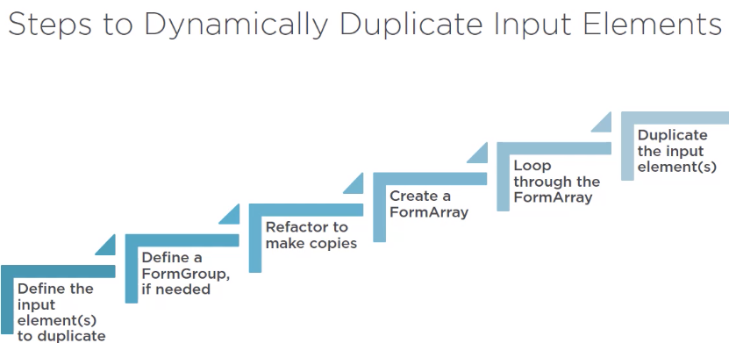

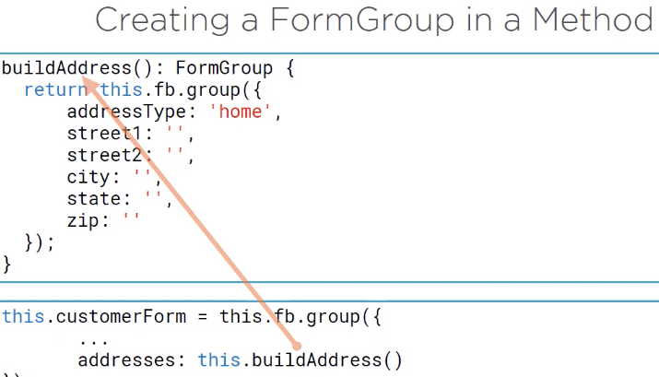

 

-group of FormGroup/Control

-accessed by index, while FormGroup uses name

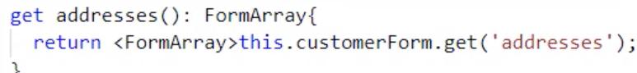

-<FormArray> is a cast operator to cast it to the desired type otherwise it is AbsrtractControl type

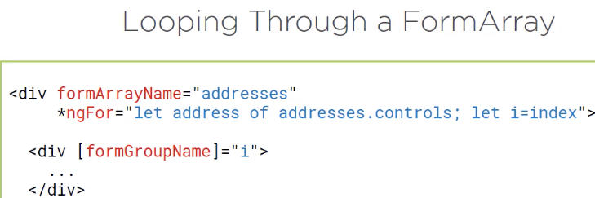

Why do we need to have square brackets? Because it is a variable??

I think because of i

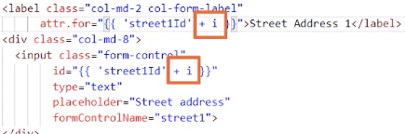

-Now that we will have multiple copies, we need to make sure label is associated with the correct input element

-For ‘for’ attribute we can’t bind to the attribute directly because it has no associated DOM property. Instead use attribute binding

-The screen reader will associate the correct label with the correct copy of the input box

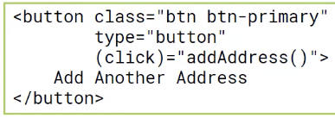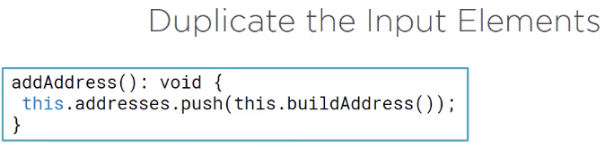



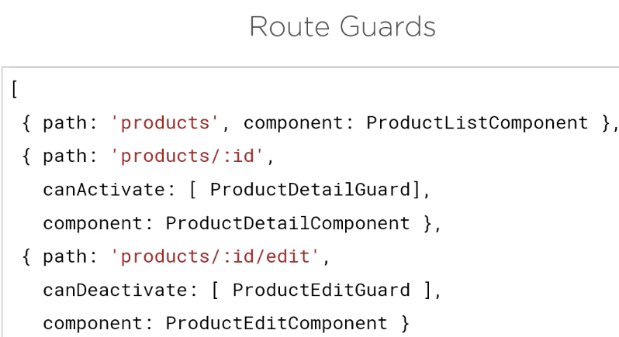

-canDeactivate is used for when user has unsaved changes?

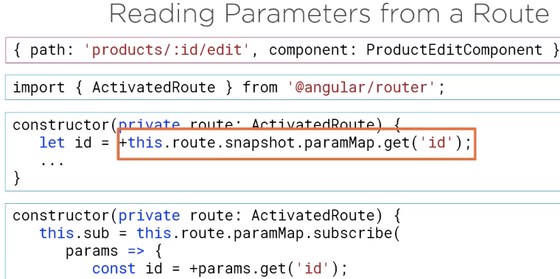

-Use a snapshot if you only need to get the initial value of the parameter

-If you expect the parameter to change without leaving the page, use an observable instead

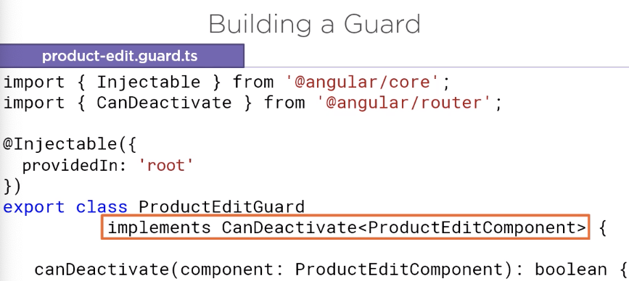

-canDeactivate includes a generic parameter that specifies the associated component

-returns a True: to deactivate the route, False: to cancel the route activation but can also return an observable or a promise for complex cases

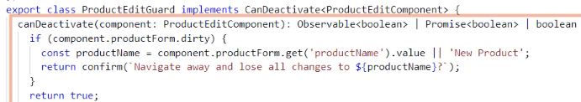

-can access the component properties

CRUD

-Working with HTTP requests and responses requires working asynchronously

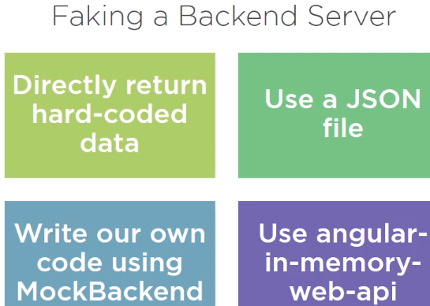

-Hard code Data does not use Angular HTTP service

-JSON file is good for GET but not PUT & POST

-MockBackend is a chore

-To use web-api make sure it is in package.json file for devDendencies-

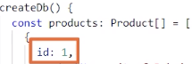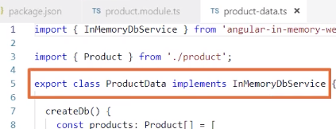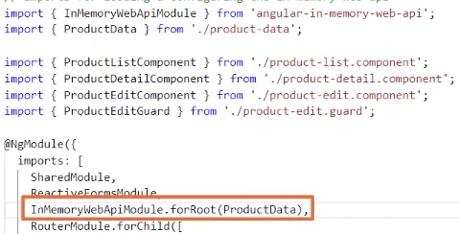

-ProductData implements InMemoryService and must create createdDb()

-Using id is required for the in-memory Web API service

-It retains data in memory but if app restarts it is reinitialized

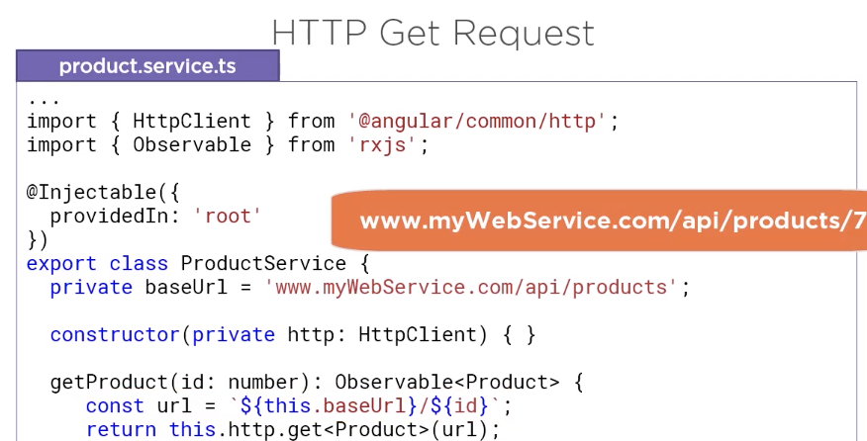

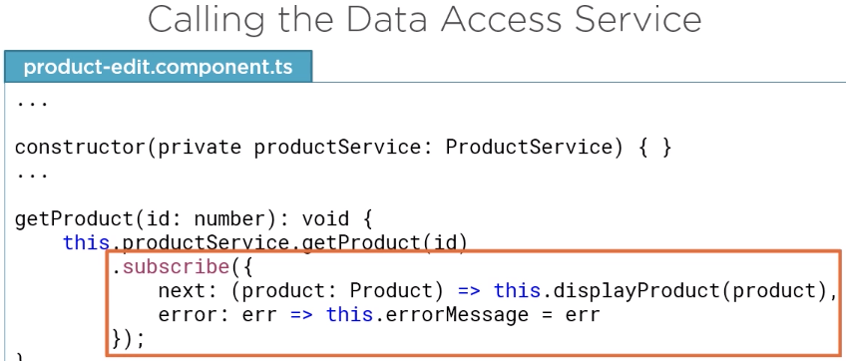

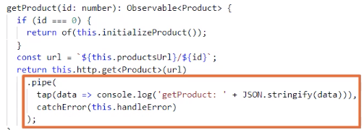

-tap operator taps into the observable stream without modifying it. Great for logging/debugging

-carchError operator catches any errors returned by the HTTP get method

Name=”firstName”

So the formcontrol instance is associated correctly in the form model

#firstNameVar=”ngModel”

Template reference variable to use for validation styling and messages

When to create a instance or a Class?

